

**www.monash.edu**

**PhD Scholarship in Upconverted Perovskite Solar Cells**

**Position Summary**

We are looking for a prospective graduate student interested in nanomaterials and solar cell devices to work on an ARC Centre of Excellence in Exciton Science (ACEx) funded project. The goal of the project is to develop a new type of solar cell device that can efficiently upconvert light to extend the absorption range of perovskite solar cells.

**ARC Centre of Excellence in Exciton Science (ACEX):** ACEx is an ARC funded research centre that brings 5 Australian universities (Melbourne, Monash, RMIT, Sydney and UNSW) and numerous international partners together to research better ways to manipulate the way light energy is absorbed, transported and transformed in advanced molecular materials.

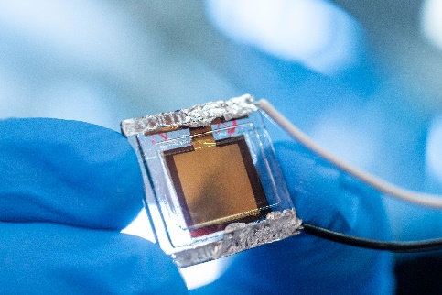**Project Outline:** Metal halide perovskite solar cells have rapidly emerged as leading contenders for next-generation photovoltaic applications. While leading light to electricity conversion efficiencies of these devices being at >25%, there is a real opportunity to use these materials in device structures that can go beyond the Schockley-Queisser photovoltaic limits. One approach is to couple perovskite devices with high efficiency up-conversion processes to extend the practical absorption range of the solar cell. This project will explore this idea by selectively developing optimal upconversion perovskite solar cell devices. The project will be split between Monash University (Prof. Jacek Jasieniak) and UNSW (Prof. Tim Schmidt), who individual have leading expertise in perovskite solar cells and upconversion, respectively.

**Selection criteria**

**ESSENTIAL**

* Undergrad in Eng or Science with a background in advanced materials, solar cells or related areas;
* H1 or equivalent GPA in studies.
* Demonstrated research experience.
* Demonstrated ability to work independently and as part of a team;
* Demonstrated organisation skills, time management and ability to work to priorities;
* Excellent written and oral communication skills.

**DESIRABLE**

* One or more publications in a high impact journal.
* Experience in the synthesis of functional optical materials, thin film deposition and characterisation, electron microscopy.

**SALARY LEVEL** A$29,000 p.a. stipend (tax-free)

**START DATE** Available now.

**EMPLOYMENT TYPE** Stipends are available for minimum 3 years, subject to satisfactory progress.

**CONTACT** Prof Jacek Jasieniak, Email: jacek.jasieniak@monash.edu