

**www.monash.edu**

**PhD Scholarship in Structural Engineering of Perovskite Interfaces**

**Position Summary**

We are looking for a prospective graduate student interested in the fundamental design of material interfaces. The specific focus of the project will be on the interfacial evolution of metal halide perovskites.

**ARC Centre of Excellence in Exciton Science (ACEX):** ACEx is an ARC funded research centre that brings 5 Australian universities (Melbourne, Monash, RMIT, Sydney and UNSW) and numerous international partners together to research better ways to manipulate the way light energy is absorbed, transported and transformed in advanced molecular materials.

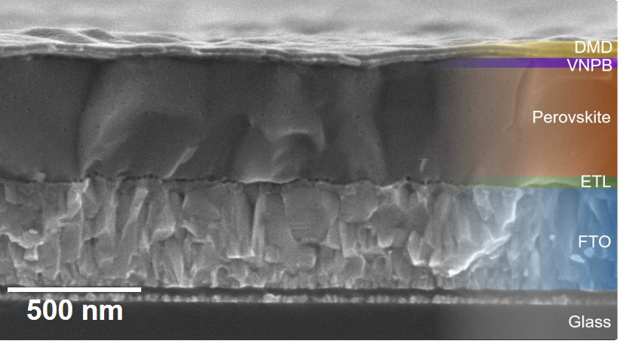

**Project Outline:** Metal halide perovskite solar cells have rapidly emerged as leading contenders for next-generation photovoltaic, sensing and light emitting applications. Underlying each of these areas is the integration of the perovskite materials within an engineered device architecture. However, the interfacing of perovskites with other layers within such devices remains poorly understood. As a result, the notion of forming an optimal perovskite interface to improve device efficiencies, stability and functionality cannot be achieved without new knowledge being developed. In this project, you will work within a team of materials engineers, physicists, chemists and microscopists to probe the structural nature of the perovskite interface in order to address one question: how does a perovskite interface develop? This exciting and multi-disciplinary project is the state-of-the-art and call for somebody who is inquisitive, committed and wants to make a difference.

**Selection criteria**

**ESSENTIAL**

* Undergrad in Eng/Science with a background in materials, electronic devices or related areas;
* H1 or equivalent GPA in studies.
* Demonstrated research experience.
* Demonstrated ability to work independently and as part of a team;
* Demonstrated organisation skills, time management and ability to work to priorities;
* Excellent written and oral communication skills.

**DESIRABLE**

* One or more publications in a high impact journal.
* Experience in the functional materials, thin film deposition and characterisation, electron microscopy.

**SALARY LEVEL** A$29,000 p.a. stipend (tax-free)

**START DATE** Available now.

**EMPLOYMENT TYPE** Stipends are available for minimum 3 years, subject to satisfactory progress.

**CONTACT** Prof Jacek Jasieniak, Email: jacek.jasieniak@monash.edu