

**www.monash.edu**

**PhD Scholarship in Optoelectronic Properties of Perovskite Solar Cells**

**Position Summary**

We are looking for a prospective graduate student interested in interfaces and solar cell devices to work on an ARC Centre of Excellence in Exciton Science (ACEx) funded project. The goal of the project is to develop a more complete understanding into the optoelectronic properties of existing & emerging perovskite solar cells.

**ARC Centre of Excellence in Exciton Science (ACEX):** ACEx is an ARC funded research centre that brings 5 Australian universities (Melbourne, Monash, RMIT, Sydney and UNSW) and numerous international partners together to research better ways to manipulate the way light energy is absorbed, transported and transformed in advanced molecular materials.

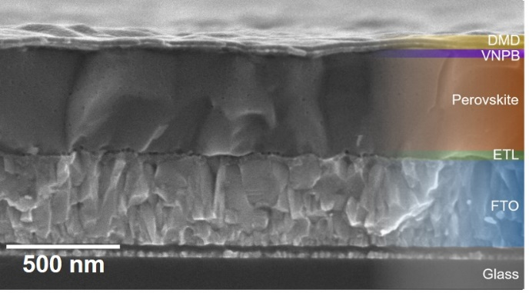**Project Outline:** Metal halide perovskite solar cells have rapidly emerged as leading contenders for next-generation photovoltaic applications. Despite light to electricity conversion efficiencies of these devices being at >25%, there is still a general lacking in understanding as to how these device work. In this project we will study the charge transport within the different perovskite absorbers and across tuned interfaces to gain an understanding of how charges evolve in a perovskite device in time, space and energy. The project will involve the development of structurally controlled perovskite devices, understanding their underlying photophysics and developing detailed simulations of the operating devices to attain a quantitative understanding of their device operation.

**Selection criteria**

**ESSENTIAL**

* Undergrad degree in Eng or Science with a background in optical materials, solar cells, or related areas;
* H1 or equivalent GPA in studies.
* Demonstrated research experience.
* Demonstrated ability to work independently and as part of a team;
* Demonstrated organisation skills, time management and ability to work to priorities;
* Excellent written and oral communication skills.

**DESIRABLE**

* One or more publications in a high impact journal.
* Experience in thin film deposition and characterisation, electron microscopy, AFM, optical device simulation.

**SALARY LEVEL** A$29,000 p.a. stipend (tax-free)

**START DATE** Available now.

**EMPLOYMENT TYPE** Stipends are available for minimum 3 years, subject to satisfactory progress.

**CONTACT** Prof Jacek Jasieniak, Email: jacek.jasieniak@monash.edu