

**www.monash.edu**

**PhD Scholarship in High-Efficiency Semi-Opaque Perovskite Solar Cells**

**Position Summary**

We are looking for a prospective graduate student interested in nanomaterials and solar cell devices to work on an ARC Centre of Excellence in Exciton Science (ACEx) funded project. The goal of the project is to develop a new type of solar cell device based on the perovskite call of materials that provides high light transparency while simultaneously optimising for light-to-electricity conversion.

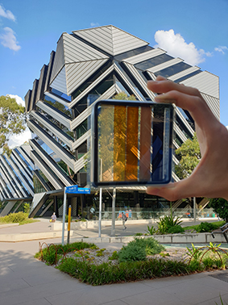**ARC Centre of Excellence in Exciton Science (ACEX):** ACEx is an ARC funded research centre that brings 5 Australian universities (Melbourne, Monash, RMIT, Sydney and UNSW) and numerous international partners together to research better ways to manipulate the way light energy is absorbed, transported and transformed in advanced molecular materials.

**Project Outline:** Metal halide perovskite solar cells have rapidly emerged as leading contenders for next-generation photovoltaic applications. While leading light to electricity conversion efficiencies of these devices being at >25%, there is a real opportunity to use these materials in device structures that provide new functionality that conventional silicon solar cells simply cannot achieve. One of these is the practical realisation of solar windows. Our existing work in the area on semi-transparent solar cell device architectures has shown record efficiencies for most average visible transmittance values. In this project, you will work within a team to develop the concept of a semi-opaque perovskite solar cell. The project will involve solar cell device fabrication and characterisation, module development and simulation. It is an applied project, that will be aligned strongly to industry partners.

**Selection criteria**

**ESSENTIAL**

* Undergrad in Eng or Science with a background in advanced materials, solar cells or related areas;
* H1 or equivalent GPA in studies.
* Demonstrated research experience.
* Demonstrated ability to work independently and as part of a team;
* Demonstrated organisation skills, time management and ability to work to priorities;
* Excellent written and oral communication skills.

**DESIRABLE**

* One or more publications in a high impact journal.
* Experience in the thin film deposition and characterisation, optoelectronic devices and/or perovskites.

**SALARY LEVEL** A$29,000 p.a. stipend (tax-free)

**START DATE** Available now.

**EMPLOYMENT TYPE** Stipends are available for minimum 3 years, subject to satisfactory progress.

**CONTACT** Prof Jacek Jasieniak, Email: jacek.jasieniak@monash.edu